POSTGRESQL Installation Guide

**Step 1: Copy paste the below link in the Chrome Browser.**

<https://www.enterprisedb.com/downloads/postgres-postgresql-downloads>

Note: We are downloading the windows X64

**Step 2: Download the PostgreSQL version - 13**

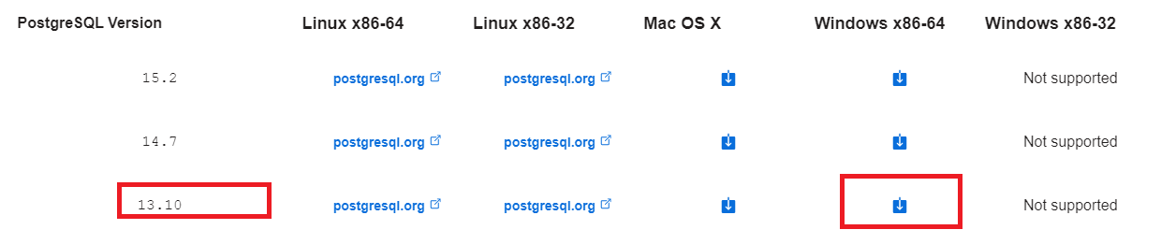

**Step 3: Click on the Windows X86-64 based on your system capability.**

After successful download, double click on the postgresql-13.4-1-windows-x64.exe file.

Proceed with the installation as below

<https://www.guru99.com/download-install-postgresql.html>